**CALCIUM CARBONATE**

**HERO**

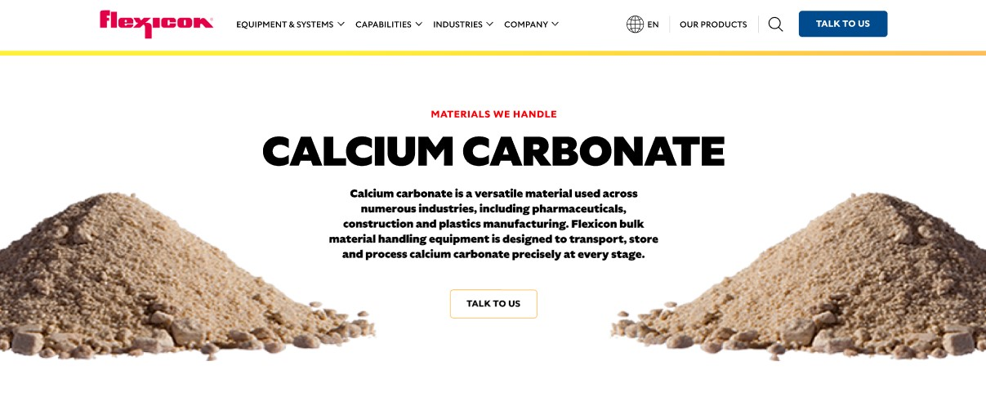

Calcium carbonate is a versatile material used across numerous industries, including pharmaceuticals and plastics manufacturing. Flexicon bulk material handling systems are engineered to move, store, and convey calcium carbonate with precision throughout your process.

**Button**: Talk To Us

**SHELF #1 - PRODUCT DESCRIPTION**

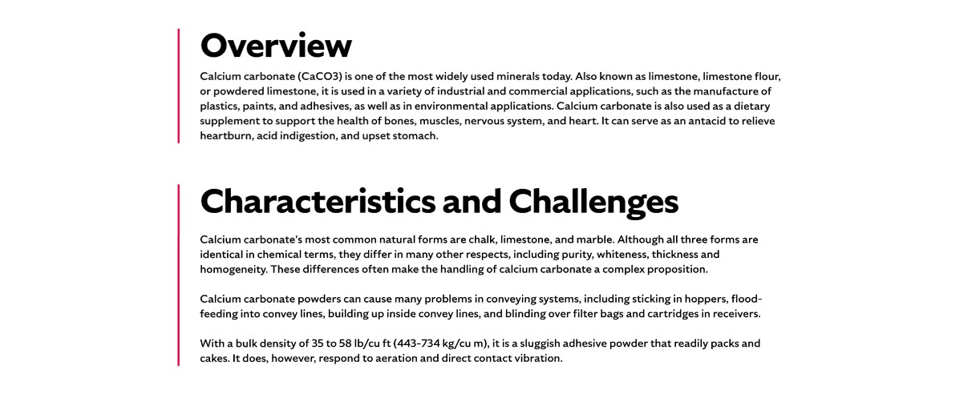

**Overview**

Calcium carbonate (CaCO₃), also known as limestone, limestone flour, or powdered limestone, is one of the most widely used and versatile minerals in the world. It plays a critical role across industries—from enhancing the performance of plastics, paints, and adhesives to supporting environmental efforts like water treatment and soil stabilization. In the health and wellness space, calcium carbonate is valued as a dietary supplement that helps maintain strong bones, healthy muscles, a balanced nervous system, and a resilient heart. Whether you're developing industrial products or promoting personal well-being, calcium carbonate delivers consistent, proven benefits.

**Characteristics and Challenges**

Calcium carbonate’s most common natural forms are chalk, limestone, and marble. Although all three forms are identical in chemical terms, they differ in many other respects, including purity, whiteness, thickness, and homogeneity. These differences often make the handling of calcium carbonate a complex proposition.

With a bulk density of 35 to 58 lb/cu ft (443-734 kg/cu m), Calcium carbonate powders can cause many problems in conveying systems, including sticking in hoppers, flood-feeding into convey lines, building up inside convey lines, and blinding over filter bags and cartridges in receives.

**SHELF #2 - FLEXICON SOLUTIONS**

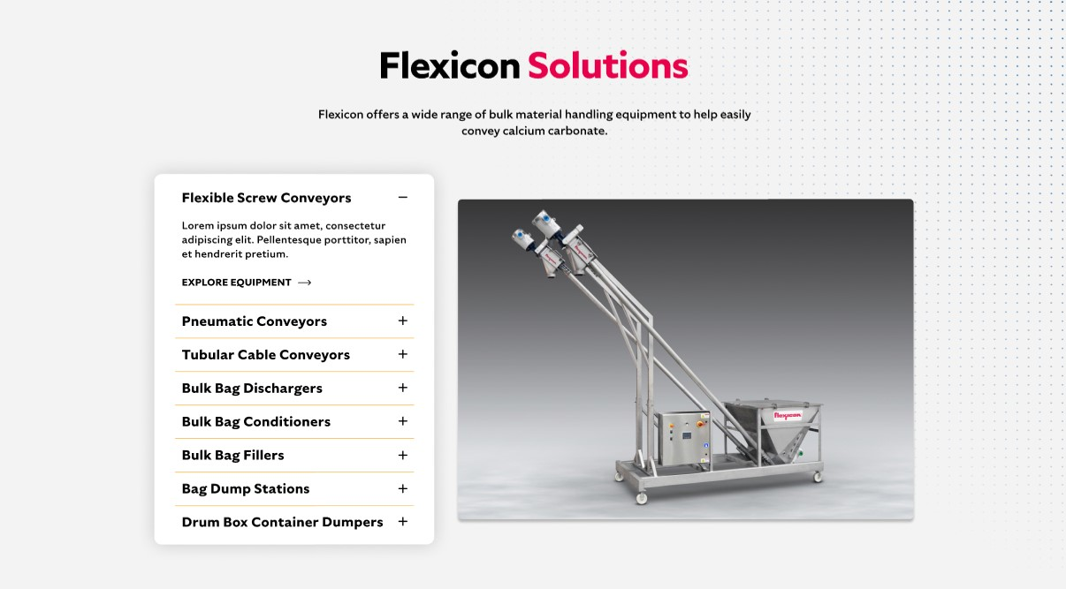

**Flexicon Solutions**

Flexicon offers a wide range of bulk material handling equipment to help easily convey calcium carbonate.

* **Flexible Screw Conveyors:** Convey calcium carbonate smoothly while minimizing material degradation.
* **Pneumatic Conveyors**: Transport calcium carbonate efficiently over long distances and varying elevations.
* **Tubular Cable Conveyors**: Provide enclosed, dust-free handling for clean and safe transport.
* **Bulk Bag Dischargers**: Bulk bag dischargers with spout locking and dust‑containment features enable safe, dust‑tight unloading of calcium carbonate from bulk bags into downstream conveying systems.
* **Bulk Bag Conditioners**: Loosen compacted calcium carbonate in bulk bags to promote consistent, controlled flow during discharge.
* **Bulk Bag Fillers:** Equipped with densification decks, load‑cell controls and sealing systems ensure calcium carbonate is filled into bulk bags to target weight.
* **Bag Dump Stations**: Dust hoods, filtration and pneumatic pulse cleaners support manual dumping of calcium carbonate with efficient dust control.
* **Drum/Box/Container Dumpers:** Drum or container dumpers safely transfer calcium carbonate from smaller containers into receiving hoppers or conveyors while minimizing dust escape and manual handling risks.

**SHELF #3: LIFETIME PERFORMANCE GUARANTEE**

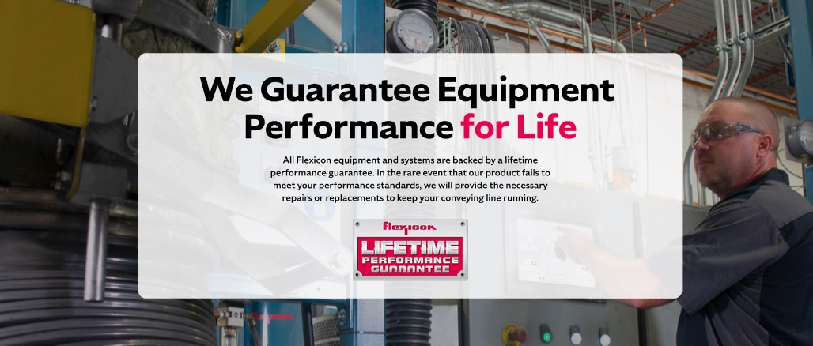

**Lifetime Performance Guarantee**

All Flexicon equipment and systems are backed by a lifetime performance guarantee. In the rare event that our product fails to meet your performance standards, we will provide the necessary repairs or replacements to keep your conveying line running.

**SHELF #4: CASE STUDIES**

